FACE DETECTION IN IMAGE USING

PYTHON

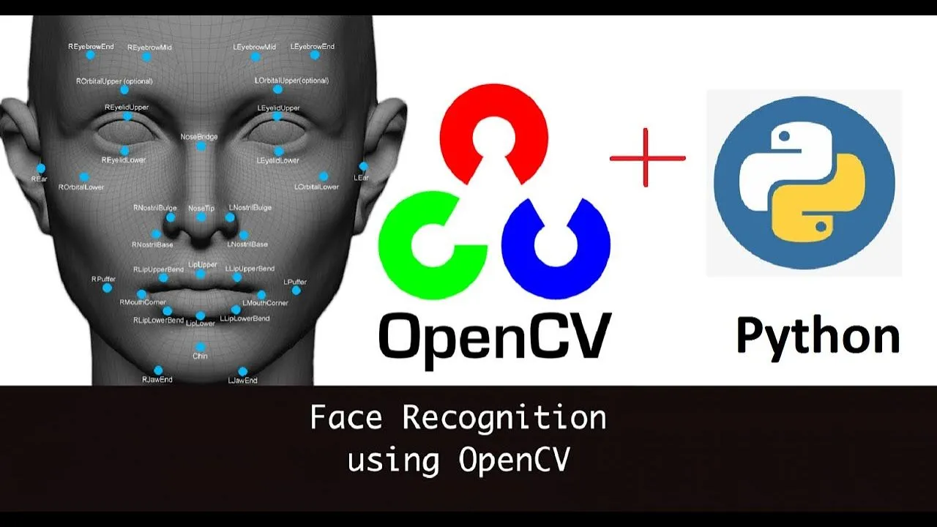

Prepared by: - Guided by: -

Aryan Harihara Behera Milan Das

Asish Pradhan

Biswajit Panigrahi

Debabrata Swain

Vivekananda Patri

SYNOPSIS

**Title: Face Detection in Images Using Python**

**Objective**: The objective of this project is to develop a Python-based application capable of detecting faces in images. This will involve utilizing a dataset of annotated images, implementing a face detection algorithm, and displaying the detected faces with bounding boxes.

**Tools and Libraries**:

* **Python**: The programming language used for the project.
* **OpenCV**: A powerful library for computer vision tasks.
* **dlib**: A toolkit containing machine learning algorithms, especially useful for face detection.
* **NumPy**: A library for numerical operations in Python.
* **Matplotlib**: A plotting library for visualizing the results.

**Dataset**: A small dataset of annotated images with faces will be used. This dataset contains images where the faces have been manually labeled with bounding boxes.

**Methodology**:

1. **Data Preparation**:
   * Load the dataset of annotated images.
   * Preprocess the images, if necessary (resizing, normalization, etc.).
2. **Face Detection Algorithm**:
   * Utilize pre-trained models such as Haar cascades or Histogram of Oriented Gradients (HOG) with Support Vector Machines (SVM) from OpenCV or dlib.
   * Implement the face detection algorithm to identify faces in the images.
3. **Visualization**:
   * Draw bounding boxes around detected faces.
   * Display the images with the detected faces highlighted.
4. **Evaluation**:
   * Assess the performance of the face detection algorithm using metrics such as precision, recall, and F1-score.
   * Compare the results with the annotated ground truth.
5. **Optimization**:
   * Fine-tune the parameters of the detection algorithm to improve accuracy.
   * Explore alternative algorithms or techniques to enhance performance.
6. **Deployment**:
   * Develop a simple graphical user interface (GUI) or a command-line tool to allow users to upload images and see the face detection results.

**Expected Outcome**: The expected outcome is a functional face detection system that can accurately identify and mark faces in images. The system should be able to handle a variety of images with different lighting conditions, facial expressions, and orientations.

**Abstract**

Face detection is a crucial technology underpinning various applications in security, photography, and human-computer interaction. This project aims to implement a face detection system using Python, leveraging powerful libraries such as OpenCV and dlib. By utilizing a dataset of annotated images, the project will demonstrate the process of detecting faces and marking them with bounding boxes. The methodology includes data preparation, algorithm implementation, result visualization, and performance evaluation. The ultimate goal is to create an efficient and accurate face detection tool that can be easily deployed for practical use, thereby showcasing the potential of Python in the field of computer vision.

**Gantt Chart**

Given the updated timeline from 16 July to 10 August, the project tasks will need to be further condensed. Here's a revised Gantt chart to fit within this shorter timeframe:

Project Timeline: Face Detection in Images Using Python (16 July - 14 August)

**Week 1: Project Planning and Setup (16 July - 19 July)**

1. **Project Planning (16 July)**
   * Define project scope and objectives.
2. **Setup Environment (17 July)**
   * Install Python, OpenCV, dlib, NumPy, Matplotlib.
   * Verify installations.
3. **Load Dataset (18 July)**
   * Load annotated images.
   * Verify data integrity.
4. **Preprocess Images (19 July)**
   * Resize images.
   * Normalize images.

**Week 2: Face Detection Algorithm (22 July - 26 July)**

1. **Select and Implement Algorithm (22-24 July)**
   * Choose between Haar cascades, HOG + SVM.
   * Implement chosen algorithm.
2. **Testing Algorithm (25-26 July)**
   * Test algorithm on sample images.
   * Debug and refine implementation.
3. **Draw Bounding Boxes (29 July)**
   * Implement code to draw bounding boxes on detected faces.
4. **Display Results (30-31 July)**
   * Display images with bounding boxes using Matplotlib.

**Week 3: Evaluation and Optimization (1 August - 7 August)**

1. **Evaluate Algorithm (1-2 August)**
   * Calculate precision, recall, F1-score.
   * Compare results with ground truth.
2. **Analyze Results (5 August)**
   * Identify areas of improvement.
3. **Parameter Tuning (6-7 August)**
   * Adjust parameters to improve accuracy.
4. **Explore Alternatives (8 August)**
   * Experiment with different algorithms or technique

**Week 4: Deployment and Finalization (9 August - 14 August)**

1. **Develop User Interface (9-12 August)**
   * Create a GUI or command-line tool.
   * Implement image upload and display features.
2. **User Testing (13 August)**
   * Test deployment with sample users.
   * Collect feedback.
3. **Documentation (14 August)**
   * Document code and usage instructions.
4. **Final Review (14 August)**
   * Review entire project.
   * Make final adjustments.
5. **Project Presentation (14 August)**
   * Prepare presentation materials.
   * Present project to stakeholders.
6. **Buffer Time (14 August)**
   * Final adjustments and contingencies.